EXP2-2 Twists and Turns Report
Che Xuanming, Yi Wanming, Zhou Mo, Wang Yibo, Wu Ximing, Wang Xinye
1. Introduction
This experiment aims to determine the shear modulus (G) of a metal wire and a polymer wire, as well as the damping behaviour (tanδ) of the polymer wire, using a torsional pendulum system, while evaluating measurement uncertainties. Traditional tensile tests indirectly calculate G by using $G=\frac{E}{2(1+ν)}$, but face limitations: E measurements are error-prone due to eccentric loading or plastic deformation, and large strains induce nonlinear errors. The torsional approach is better for polymers, where static tensile tests may misrepresent elastic properties due to plasticity or alignment errors.
The torsional pendulum method overcame traditional problems and applies pure shear loading to establish a linear relationship between the squared oscillation period and wire length ($G=\frac{4πLmR^{2}}{r^{4}T^{2}}$), avoiding combined stress interference and can directly measure G. For the polymer wire, amplitude decay ($ln\frac{A_{0}}{A_{n}}$ vs. n) yields damping parameters ($Q=\frac{π}{κ}$, $tanδ=1/Q$), enabling simultaneous characterization of elastic and viscoelastic properties.
2. Method
The G was measured using a torsional pendulum system by recording T at varying wire L. For the polymer wire, damping behaviour was analysed through logarithmic amplitude decay over successive oscillations. The details can be found in Ref [1]
3. Results
When calculating uncertainty, it is usually to consider the error of calibration, resolution, and repetition, which the following formula can calculate：
 | $$U_{Caliburation}= Mean Value*Instrument Specification/1.96$$ | ①
 | $$U_{Resolution}= Deviation/(2*\sqrt{3})$$ | ②
 | $$U_{Repeated}= SD/\sqrt{n}$$ | ③
 | $\frac{U_{Combined}}{Mean}=\sqrt{{(\frac{U_{Calibration}}{Mean})}^{2}+{(\frac{U_{Resolution}}{Mean})}^{2}+{(\frac{U_{Repeated}}{Mean})}^{2}}$ | ④
 | $$U_{Total}= U_{Combined}*1.96$$ | ⑤
Furthermore, when calculating the combined uncertainty of T in section 3.1, it is also necessary to consider a human-set reaction time of 0.1 seconds, denoted as： $U_{Reactivity}= 0.1/\sqrt{3}$⑥
3.1 Shear Modulus G
According to the original formula of the shear modulus G, the equation between the square of the oscillation period and the length of the metal/polymer wire can be obtained, which passes through the origin (0,0).
 | $G=\frac{4πmLR^{2}}{r^{4}T^{2}} \overset{⇒}{ }$ $T^{2}=\frac{4πmR^{2}}{r^{4}G}L$ | ⑦
By processing the raw data, a linear fitting curve of $T^{2}-L$ (Fig.1) can be constructed for the two materials. The error bars are derived from the total uncertainty (at 95% confidence level) and can be calculated using Equation ①②③④⑤⑥. The best-fit slopes are $k_{m}=$64.32s²/m and $k_{p}=$1551.03s²/m.
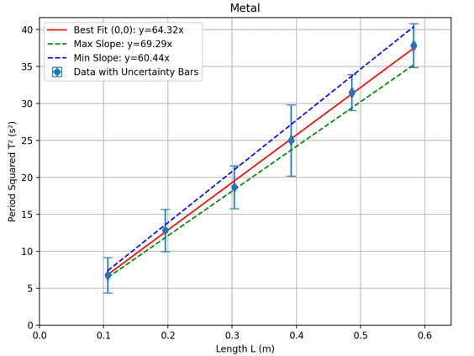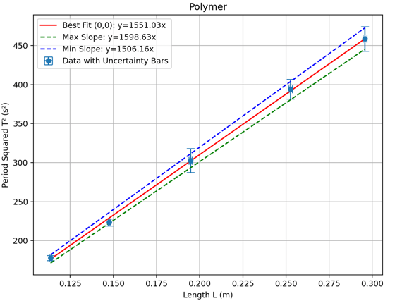
Fig.1 Linear fitting curve $T^{2}-L$ for metal wire and polymer wire.
Then based on the data: $m=1080g, R=0.06147m\text{,} r_{Metal}=0.0003150m, r_{Polymer}=0.0005027m$
It can be obtained that $G_{metal}=80.97 GPa ,G_{polymer}=0.5178 GPa$
The error bars in Fig.1 indicate a 95% probability that the true value lies within it and can help to calculate the combined uncertainty of the slope $k\left(\frac{T^{2}}{L}\right)$ , which can be expressed as:
 | $$u\left(k\right)=\frac{{Slope}_{max}-{Slope}_{min}}{2}$$ | ⑧
Moreover, the uncertainty of $m, r, R$can be calculated by the formulas ①②③④⑤⑥. Therefore, the total uncertainty of shear modulus G can be calculated as:
 | $$\frac{U(G)}{G}=\sqrt{{\left(\frac{u\left(m\right)}{m}\right)}^{2}+{\left(\frac{2u\left(R\right)}{R}\right)}^{2}+{\left(\frac{4u\left(r\right)}{r}\right)}^{2}+{\left(\frac{u\left(k\right)}{k}\right)}^{2}}$$ | ⑨
Then it can be obtained that the total uncertainties of G of metal and polymer wires are${ U}_{Gtotal-metal}=8.564 GPa , U_{Gtotal-polymer}=0.0309 GPa.$ And the shear modulus for two wires can be expressed as $G_{metal}=80.97 ± 8.564 GPa ,G_{polymer}=0.5178 ± 0.0309 GPa.$
3.2 Damping factor Q for polymer wire
For polymer wire, torsional pendulum experiments were conducted at five distinct lengths L. Record the initial amplitude A₀ and amplitude A_{n} at the n^{th} cycle, with each data set collected over 5 cycles. The logarithmic decrement κ can be calculated by the slope of linear fitting of $ln\frac{A_{0}}{A_{n}}-n$ plots (Fig.2). All regression lines were constrained to pass through the origin (0,0) to ensure alignment with theoretical assumptions.
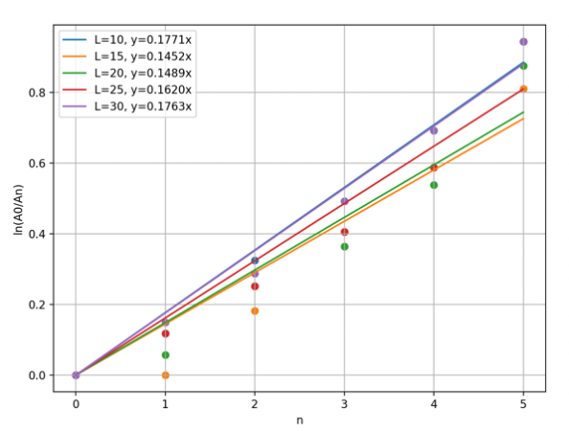
Fig.2 $ln\frac{A_{0}}{A_{n}}-n$ plots for polymer wire.
Since κ embodies the intrinsic properties of the polymer wire, its value remains unaffected by the wire’s length. This situation is akin to performing five repeated measurements of the κ value within this group. Consequently, the uncertainty of κ can be calculated by ③:
$u\left(κ\right)=\frac{SD}{\sqrt{5}}*1.96=$0.013047624
According to the formula:
 | $$Q=\frac{π}{κ} and tanδ=\frac{1}{Q}$$ | ⑩
As${ Q}_{average}=$19.4045$, u\left(Q\right)=\frac{π}{κ^{2}}·u\left(κ\right)=1.5638, Q_{polymer}=19.4045±1.5638$
4. Discussion
4.1 Uncertainty analysis
Based on the ①②③④⑤⑥⑦⑧⑨ calculated uncertainties shown in Table 1, it can be concluded that the magnitude of $\frac{U_{r}}{r}$ and $\frac{U_{k}}{k}$ are the largest, being roughly ten times higher than uncertainties from other parameters. This means the measurement of r and k have the most significant impact on the overall uncertainty of G. At the same time, the largest source of uncertainty of damping factor Q is κ.

The reduction of uncertainty can be achieved from the following two perspectives:
- Key parameter measurement optimization: Parameters r and the slope of T² versus L are critical. Conducting more measurements at multiple locations significantly reduces the repeated measurement uncertainty of r. Since large errors in T affect total uncertainty, refined how the slope of T² versus L influences the final uncertainty of G.
- Instrument and operation improvement: The use of more advanced instruments such as high-speed cameras, laser goniometer, etc. to reduce the error of artificial reading, while the standard operation in the process of experimental operation, to maintain the natural relaxation of the wire, to avoid the crimped stress during storage or installation. Ensure that there is no initial speed when releasing the disc, preventing the introduction of additional oscillation modes by shaking up and down. Measurement on a vibration-free bench to reduce external interference.
Table 1. Uncertainty budget
Parameters | Mean | Calibration | Resolution | Repeated | Combined | Total | $$\frac{U_{X}}{X}$$
m (g) | 1070 | 0. 5493 | 0. 28868 | 0 | 0.6221 | 1.219 | 0.00113
R (mm) | 61.47 | 0.09408 | 0.2887 | 0.14530 | 0.33659 | 0.65973 | 0.00107
r_{m} (mm) | 0.3150 | 0.0000804 | 0.002887 | 0.001155 | 0.003110 | 0.006096 | 0.01178
r_{p} (mm) | 0.50277 | 0.000128 | 0.002887 | 0.000882 | 0.003021 | 0.005922 | 0.01935
$$κ$$ | 0.1619 | / | / | 0.006657 | 0.006657 | 0.013048 | 0.08059
k_{metal} (s²/m) | 64.32 | / | / | / | / | 4.425 | 0.06880
k_{polymer} (s²/m) | 1551.03 | / | / | / | / | 46.235 | 0.02981

4.2 Precision and accuracy analysis
Referring to the methodology in EXP2-1^{[2]}, the Coefficient of Variation (CV) quantifies the distribution width or sharpness relative to the mean value, which can be computed by the formula: $CV=\frac{SD}{Mean}×100\%$. And the standard of CV is shown below, a lower CV signifies reduced relative variability, reflecting higher precision or consistency within the dataset.
$$CV < 1\%$$ | Very precise
$$CV<10\%$$ | Precise
$$CV>30\%$$ | Imprecise (High relative variability)
As mentioned in 4.1, for the shear modulus G, the maximum sources of uncertainty are r, T and L. Then, the CV of them can be obtained:
For r, ${CV}_{r-polymer}=3\%<10\% Precise {CV}_{r-metal}=6.3\%<10\% Precise$
For T, ${CV}_{T-polymer}=1.36\%<10\% Precise {CV}_{T-metal}=7.9\%<10\% Precise$
For L, ${CV}_{L-polymer}=0.32\%<1\% Very Precise {CV}_{L-metal}=0.27\%<1\% Very Precise$
For Q, ${CV}_{Q}=9.31\%<10\% Precise$
The CV analysis for parameters r, T, L and revealed values consistently below 1% or 10%, indicating high precision and reproducibility in these measurements. In contrast, the distribution of damping factor Q is a little bit higher than others. This discrepancy likely stems from amplitude measurement challenges caused by excessive vibrational oscillations in the polymer wire. Contributing factors include prolonged T, vertical displacement artefacts during motion, and potential systematic errors in A_{n} quantification.
Through online verification of reference shear modulus data for metal wires and polymer wires, the theoretical values are determined as$G_{metal-standard}=78.0-82.7GPa , G_{polymer-standard}= 0.514 GPa^{ \left[3\right]\left[4\right]}$ The experimentally determined G for both materials were$G_{metal}=80.97±8.564 GPa , G_{polymer}=0.5178 ± 0.0309 GPa$.These values exhibit strong alignment with established theoretical references, confirming the validity of experimental methodology and the accuracy of experimental data. The proximity of measured and theoretical G-values embodies the precision of the torsional pendulum technique in quantifying material properties.
5. Conclusion
The experiment successfully determined the G of a steel alloy metal wire and a nylon polymer wire and the damping coefficient Q, the following is a summary of the calculated results of this experiment using a torsional pendulum method.
Table 2. The result of the experiment.
Measurement targets | Average | Uncertainty | Final values | unit
$$G_{metal}$$ | 80.97 | $$±8.564$$ | $$80.97 ± 8.564$$ | GPa
$$G_{polymer}$$ | 0.5178 | $$± 0.0309$$ | $$0.5178 ± 0.0309$$ | GPa
$$Q_{polymer}$$ | 19.4045 | $$±1.5638$$ | $$19.4045±1.5638$$

Through the processing of experimental data and thinking of the experimental process, it is analyzed and discussed from the following aspects:
- The measurement of the radius (r) and uncertainty of the slope $(k)$ have the most significant impact on the overall uncertainty of G while other parameters have less effect on the overall uncertainty of G.
- Conducting more measurements at multiple locations during the experiment can significantly reduce the repeated measurement uncertainty of r.
- The online verification of reference shear modulus data for metal wires and polymer wires has exhibited strong alignment with theoretical references, confirming the validity of the experimental methodology and the accuracy of experimental data and embodies the precision of the torsional pendulum technique in quantifying material properties.
6. Reflection
The most important lessons our group learned were experimental design and the definition/calculation of uncertainties. Prior to experiments, we meticulously planned experimental procedures, hypothesized the factors with the greatest impact on uncertainty and conducted multiple measurements accordingly. However, due to conservative time estimates leading to early completion, some parameters might have insufficient repeated measurements. Conducting multiple measurements on the same parameter significantly improved the accuracy of uncertainty calculations. Initial disk release operations caused unintended oscillations due to incomplete stabilization, which were subsequently refined. Through comparative analysis of various factors, we precisely identified the primary sources of uncertainty affecting target parameters, providing valuable guidance for optimizing future experimental designs. Additionally, implementing standardized experimental protocols and employing high-precision instrumentation can enhance the reliability of experimental results.
References
[1] M9 (2025). QXU5017 EXP2-2 Part 1 Plan M9.PDF
[2] Deng Xinru. (2025). Introduction to EXP2-1 Experiments in Material.
[3] “Overview of materials for High Carbon Steel.” Matweb.com, matweb.com /search/DataSheet.aspx? MatGUID = ee25302df4b34404b21ad67f8a83e858&ckck=1.
[4] “Overview of Materials for Nylon 66/6.” Matweb.com, 2025, matweb.com/search/DataSheet.aspx?MatGUID=26386631ec1b49eeba62c80a49730dc4. Accessed 28 Mar. 2025.

